DOCAYA
Enterprise Electronic Document Management System
Database Design Document
Version 1.3
Schema design · Data model · Constraints · Indexing · Security · Traceability

Attribute | Value
Document type | Database Design Document (DDD) — physical schema baseline
Version | 1.3 — accompanies the Docaya Database Deployment Scripts v1.3
Authoritative source | Docaya Technical Architecture Document v1.3, Section 11 (Data Architecture)
Functional baseline | Docaya EDMS Functional & Business Design v1.3 · Functional & Technical Specification v1.3
Target platform | Azure SQL Database (compatible with SQL Server 2019 and later)
Companion artefacts | 16 ordered T-SQL scripts (00–15) · Docaya-Azure-SQL-Deployment-Guide-v1.3.docx
Status | Draft for Review — schema baseline subject to open items in Section 11
Classification | OFFICIAL – Internal
Date | 13 September 2026

What this document is This is the physical database design for Docaya. It explains every schema, why the schemas are separated, the core entity model, the constraints that enforce architectural rules in the database rather than only in application code, the indexing strategy, the least-privilege security model, and the traceability back to functional requirements.

1. Introduction

1.1 Purpose and Audience
This document specifies the Docaya database as built. It is written to be sufficient for a database engineer to operate the schema, for a developer to write correct data access against it, for a security reviewer to validate the permission model, and for an auditor to understand how evidential integrity is achieved.
Audience | What they should read
Database engineer | Sections 3–7 (schemas, entities, constraints, indexes) and the Deployment Guide.
Application developer | Sections 4–6 (entity model and constraints) and Section 9 (programmability).
Security reviewer | Section 8 (security model) and Section 6.3 (audit chain).
Records and compliance | Sections 5.2 (legal hold) and 6.3 (audit).
Release engineer | Section 10 (deployment summary) and the companion Deployment Guide.

1.2 Scope
In scope | Out of scope
Ten bounded schemas and 63 tables; primary, foreign, unique and check constraints; the indexing strategy; the least-privilege role and grant model; row-level security; stored procedures and functions; reporting views; seed reference data; requirement traceability. | Azure resource provisioning and the step-by-step installation runbook (see the Deployment Guide); application data-access code; the Azure AI Search index schema (TAD Section 12); SharePoint column mapping (TAD Section 13); final capacity sizing, confirmed by performance testing.

1.3 Relationship to Other Documents
Document | Relationship
Functional & Business Design v1.3 | Defines the business rules this schema enforces — the lifecycle, review chain, working-day SLA, Department Tag and Publishing Scope.
Functional & Technical Specification v1.3 | Defines the functional requirements (FR-CAP, FR-WF, FR-PUB, FR-CORE, FR-GOV) that individual constraints implement.
Technical Architecture Document v1.3 | Section 11 defines the schema separation strategy and store ownership. This document is its physical realisation.
Azure SQL Deployment Guide v1.3 | The installation runbook: provisioning, identity, script execution, validation, operations and rollback.
Database Deployment Scripts v1.3 | The 16 T-SQL files that create everything described here.

2. Design Principles
Seven principles shaped this design. Each has a concrete, testable consequence in the physical schema.
# | Principle | Consequence in the database
1 | Azure SQL is authoritative for all structured data. | The docaya schema is the system of record for metadata. SharePoint columns and the search index are projections written from it, never read as truth.
2 | Staging is transient and isolated. | stg is a separate schema with its own lifecycle and its own database principal. The capture worker is granted there and explicitly denied everywhere else.
3 | Audit must be evidentially defensible. | aud is append-only. No application principal holds UPDATE or DELETE, and a trigger enforces the same rule as defence in depth.
4 | Derived data must be disposable. | idx, ntf and rpt can be dropped and rebuilt from docaya and SharePoint. They carry no backup requirement of their own.
5 | Architectural rules belong in the database. | Exactly-once publication, mandatory return comments, the 100 MB cap and the 3–4 stage chain are CHECK and UNIQUE constraints, not conventions.
6 | Least privilege per workload. | Seven database roles, one per workload identity. There is no omnipotent account and no shared administrator in normal operation.
7 | Deletion is a governed action. | No business table permits a cascade delete. Disposition is an explicit, audited operation subject to legal hold.

The single most important data rule Azure SQL is the master for every attribute. SharePoint columns are a projection written by the promotion worker and the search index is a second projection written by the indexing worker. Neither projection is ever treated as a source of truth, and a reconcile job restores both from SQL if they drift.

3. Schema Architecture
The database contains ten bounded schemas. Separation is not cosmetic: each has a distinct lifecycle, a distinct retention profile and a distinct set of principals that may touch it.

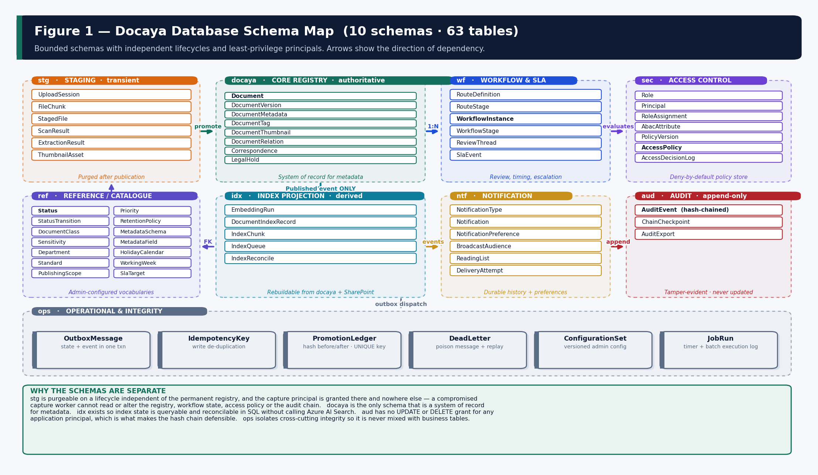
Figure 1 — The ten schemas, their tables, and the direction of dependency between them.

3.1 Schema Responsibilities
Schema | Tables | Purpose | Why it is separate
stg | 6 | Staging and upload processing. | Rows are transient and purgeable on a lifecycle independent of the permanent registry. The capture worker needs write access here and nowhere else.
docaya | 8 | Core document registry. | The only schema that is a system of record for metadata; every other schema points at it or is derived from it.
wf | 6 | Workflow, stages, thread and SLA. | High write frequency and a distinct retention profile; isolating it keeps the registry tables narrow and index-stable.
sec | 7 | Access-control policy and decisions. | Security-sensitive; separated so policy changes are independently auditable and the decision log can be retained differently.
ref | 14 | Reference data and catalogues. | Admin-configured vocabularies that change on a governance cadence, not a transactional one.
idx | 5 | Index projection state. | Lets index state be queried and reconciled in SQL without calling Azure AI Search, and makes a full rebuild verifiable.
ntf | 6 | Notification history and preference. | Large, append-heavy and separately prunable; keeps delivery detail out of the registry.
aud | 3 | Append-only hash-chained audit. | No UPDATE or DELETE grant exists for any application principal; this is what makes the chain defensible.
ops | 6 | Operational integrity. | Outbox, idempotency, dead-letter, promotion ledger, configuration sets and job runs — cross-cutting concerns kept out of business tables.
rpt | 9 views | Reporting views. | Read-only views shaped for the Power BI semantic model with row-level security applied.

3.2 Data Classification by Schema
Each schema is classified by whether its content can be reconstructed if lost. This drives the backup and recovery design.
Classification | Schemas | Recovery approach | Backup
Authoritative | docaya · wf · sec · aud | Point-in-time restore from Azure SQL backup. Cannot be reconstructed from any other source. | Yes — full
Configured | ref · ops.ConfigurationSet | Re-seeded from the release package configuration folder, or restored with the database. | Yes — or re-seed
Transient | stg | Content is in flight only. A failed promotion is replayed from the staged blob, retained until reconciliation. | Blob soft-delete
Derived | idx · rpt | Fully rebuildable from docaya plus SharePoint. Dropping and rebuilding is the recovery mechanism. | No
Prunable | ntf · ops (operational) | History may be pruned on an agreed retention schedule without affecting correctness. | Optional

4. Core Entity Model
The model has one aggregate root — docaya.Document — and four satellites around it: the approved version, the versioned business metadata, the department tag relationship and the per-version thumbnail. Workflow, access control, index projection, notification and audit all reference the document rather than owning it, which keeps the registry table narrow and index-stable as the platform evolves.

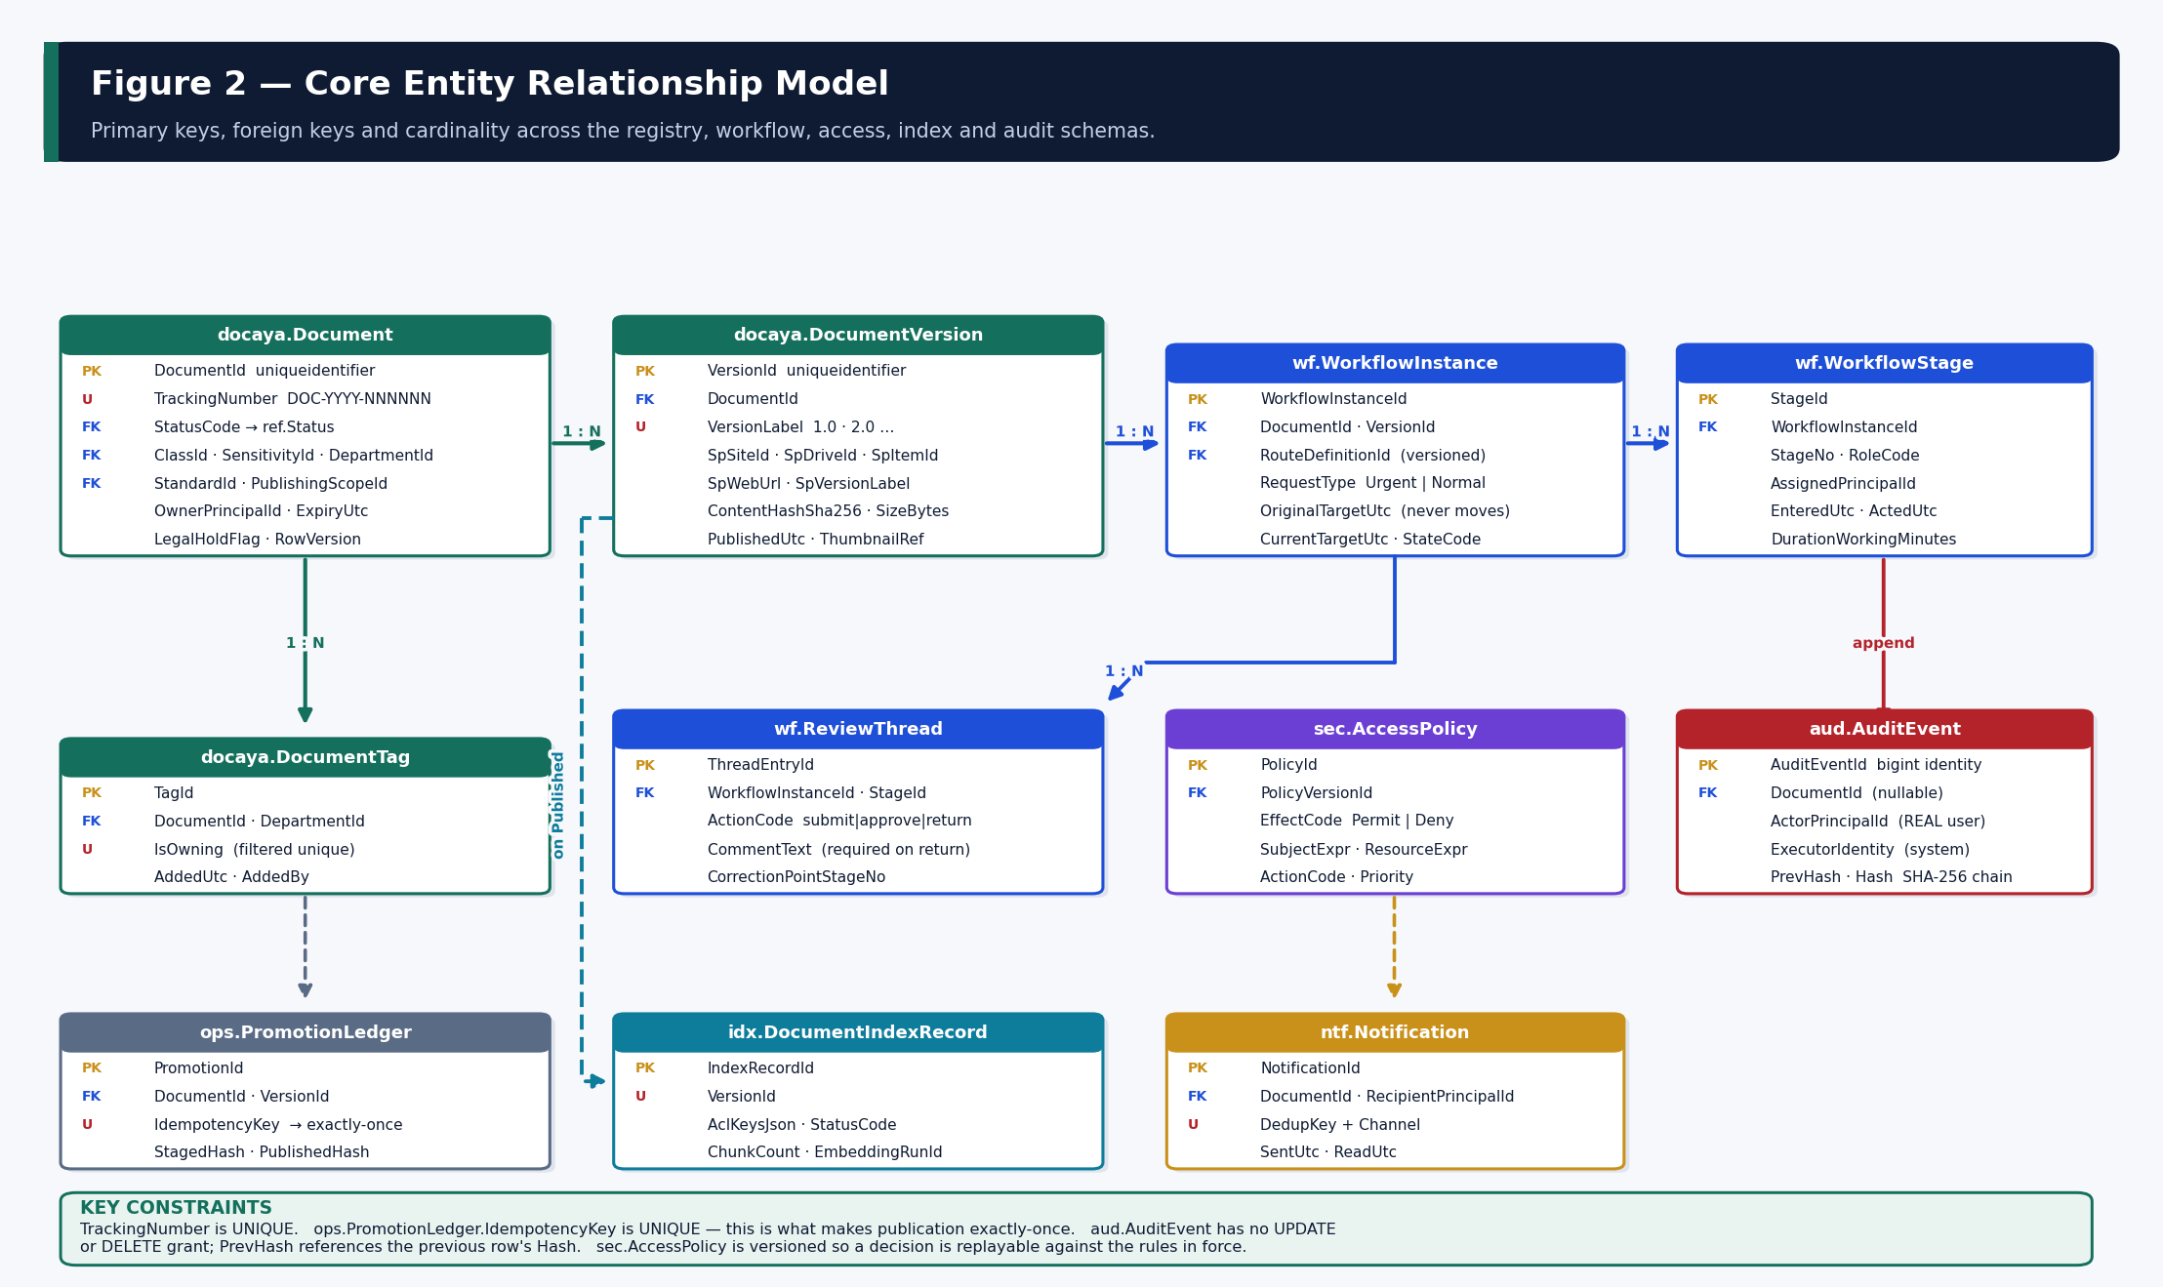
Figure 2 — Primary keys, foreign keys and cardinality across the registry, workflow, access, index and audit schemas.

4.1 The Document Aggregate
docaya.Document is the anchor of chain of custody. A row exists from the instant a tracking number is issued, and every view, edit, decision and movement is recorded against it.
Column | Type | Notes
DocumentId | uniqueidentifier | Primary key, NEWSEQUENTIALID() to reduce index fragmentation.
TrackingNumber | nvarchar(20) | UNIQUE. Format DOC-YYYY-NNNNNN, enforced by CHECK and issued by docaya.usp_IssueTrackingNumber.
StatusCode | nvarchar(24) | FK to ref.Status. Allowed transitions are held in ref.StatusTransition.
ClassId · SensitivityId · DepartmentId | int | FK to the ref catalogues. Class resolves the SharePoint library; sensitivity drives clearance checks.
StandardId | int NULL | FK to ref.Standard. Optional; drives Standard-based navigation and certification evidence.
PublishingScopeId | int | FK to ref.PublishingScope. Determines how far the publication broadcast travels.
OwnerPrincipalId | uniqueidentifier | FK to sec.Principal. The ABAC ownership predicate reads this column.
CurrentVersionId | uniqueidentifier NULL | FK to docaya.DocumentVersion. Null until the first version is published.
ExpiryUtc · DispositionDueUtc | date NULL | Drive the expiry and disposition sweeps; both indexes are filtered to exclude legal hold.
LegalHoldFlag | bit | Denormalised from docaya.LegalHold for sweep performance. Blocks archive and disposal for every role.
RowVersion | rowversion | Optimistic concurrency. A stale update is rejected rather than silently overwriting a concurrent change.

4.2 Versions and Integrity Evidence
docaya.DocumentVersion holds one row per approved version. It is written only after the promotion worker has compared the published file hash to the staged hash, so the presence of a row is itself evidence that the byte stream was published unchanged.
Column | Purpose
VersionLabel · VersionSequence | 1.0, 2.0, 3.0 … Both are UNIQUE per document; the sequence gives deterministic ordering.
SpSiteId · SpDriveId · SpItemId · SpWebUrl | The SharePoint coordinates written back after a successful Graph upload.
SpVersionLabel | The native SharePoint version. Docaya records it rather than maintaining a parallel numbering scheme.
ContentHashSha256 | binary(32). The integrity evidence, compared against ops.PromotionLedger.PublishedHash.
SizeBytes | CHECK constrains this to 100 MB, so the v1.3 single-file cap is enforced at the storage layer.
ThumbnailRef | The per-version thumbnail. Earlier thumbnails are retained against their own version.
SupersededByVersionId | Self-referencing FK. Set when a New Revision (M14) is approved and the next version is created.

4.3 Department Tag as a Relationship
Department Tag is a multi-value relationship, not a column. docaya.DocumentTag holds one row per related department with an IsOwning flag. A filtered unique index guarantees exactly one owning department per document, while allowing any number of related departments to drive navigation and broadcast reach.
-- Exactly one owning department per document
CREATE UNIQUE NONCLUSTERED INDEX UX_DocumentTag_Owning
ON docaya.DocumentTag (DocumentId) WHERE IsOwning = 1;

-- Reverse lookup: which documents belong to a department
-- (drives the browse tab and the publication broadcast audience)
CREATE NONCLUSTERED INDEX IX_DocumentTag_Department
ON docaya.DocumentTag (DepartmentId) INCLUDE (DocumentId, IsOwning);

4.4 Workflow and the Review Thread
Entity | Role in the model
wf.RouteDefinition | The versioned configured chain for a document type or department. Changing a route publishes a new VersionNo rather than editing in place.
wf.RouteStage | One row per configured stage. Holds the routing pattern (sequential, parallel, quorum, conditional), the extension authority and the final-approval flag.
wf.WorkflowInstance | A live or completed run against a document version. Holds OriginalTargetUtc and CurrentTargetUtc as separate columns so the original target can never be lost.
wf.WorkflowStage | The execution record of each stage. DurationWorkingMinutes is what makes bottleneck attribution honest — delay is assigned to a specific stage.
wf.ReviewThread | The chronological thread of every action and comment. A return is constrained to require both a comment and a correction point.
wf.SlaEvent | At-risk, overdue and extension events, each retained separately so both the original and the extended target remain visible for reporting.

Why the original target is a separate column wf.WorkflowInstance.OriginalTargetUtc is written once at submission and never updated. An authorised extension moves CurrentTargetUtc only, and a CHECK constraint prevents it from ever moving earlier. Both dates therefore remain available to analytics, which allows SLA reporting to distinguish between requests that met the original commitment and those that met an extended one.

5. Table Reference
Every table, grouped by schema. Key columns only; the deployment scripts carry the complete definition.

5.1 stg — Staging and Upload Processing
Table | Purpose | Key columns | Lifecycle
stg.UploadSession | Tracks a resumable chunked upload for exactly one file. | SessionId PK · DocumentId · TotalBytes · ReceivedBytes · StateCode · ExpiresUtc | Expires automatically; abandoned sessions cleaned nightly
stg.FileChunk | Individual chunk receipt for resume and integrity. | ChunkId PK · SessionId FK · Ordinal · ByteRange · ChunkHash | Deleted on commit
stg.StagedFile | The committed unchanged original awaiting approval. | StagedFileId PK · DocumentId FK · BlobUri · SizeBytes · MimeDetected · Sha256 | Purged, retained or moved after publication
stg.ScanResult | Malware and DLP verdict; progression is blocked until clean. | ScanId PK · StagedFileId FK · ScanType · Verdict · ScannedUtc | Retained with the audit reference
stg.ExtractionResult | Basic machine-readable text, language and page count. | ExtractionId PK · LanguageCode · PageCount · TextUri · ExtractionQuality | Retained until index build, then purgeable
stg.ThumbnailAsset | The generated preview image for this version. | ThumbId PK · DocumentId · VersionLabel · BlobUri · GenerationStatus | Promoted to the preview store on publication

Why a separate staging schema matters The capture worker's database principal is granted on stg only. Even if that worker were compromised, it could not read or alter the document registry, the workflow state, the access policy or the audit chain. Staging rows can also be truncated or archived on an entirely different schedule from the permanent record without touching business tables.

5.2 docaya — Core Document Registry
Table | Purpose | Notable columns
docaya.Document | The central registry row — the anchor of chain of custody. | TrackingNumber UNIQUE · StatusCode · ClassId · SensitivityId · DepartmentId · StandardId · PublishingScopeId · OwnerPrincipalId · LegalHoldFlag · RowVersion
docaya.DocumentVersion | One row per approved version, with SharePoint coordinates and integrity evidence. | VersionLabel · SpSiteId · SpDriveId · SpItemId · SpWebUrl · ContentHashSha256 · SizeBytes · ThumbnailRef · SupersededByVersionId
docaya.DocumentMetadata | Schema-validated business metadata, versioned by EffectiveFromUtc. | MetadataId PK · SchemaId FK · FieldKey · FieldValue · EffectiveFromUtc · EffectiveToUtc · ActorPrincipalId
docaya.DocumentTag | Department Tag as a multi-value relationship. | TagId PK · DepartmentId FK · IsOwning (filtered unique)
docaya.DocumentThumbnail | Per-version thumbnail reference and suppression flag. | ThumbnailId PK · VersionId FK · BlobUri · Suppressed
docaya.DocumentRelation | Correspondence threading and revision lineage. | RelationId PK · FromDocumentId · ToDocumentId · RelationType
docaya.Correspondence | M8 extension attributes for the Correspondence class. | ReferenceNumber UNIQUE · Direction · SenderName · RecipientName · DueUtc
docaya.LegalHold | Hold overrides retention and blocks deletion for every role. | HoldReference · Reason · AppliedBy · ReleasedUtc (filtered unique on active hold)

5.2.1 Representative DDL — the registry table
-- docaya.Document : the anchor of chain of custody.
CREATE TABLE docaya.Document (
DocumentId UNIQUEIDENTIFIER NOT NULL CONSTRAINT PK_Document PRIMARY KEY
CONSTRAINT DF_Document_Id DEFAULT (NEWSEQUENTIALID()),
TrackingNumber NVARCHAR(20) NOT NULL, -- DOC-YYYY-NNNNNN
StatusCode NVARCHAR(24) NOT NULL,
ClassId INT NOT NULL,
SensitivityId INT NOT NULL,
DepartmentId INT NOT NULL, -- owning department
StandardId INT NULL,
PublishingScopeId INT NOT NULL,
OwnerPrincipalId UNIQUEIDENTIFIER NOT NULL,
CurrentVersionId UNIQUEIDENTIFIER NULL,
ExpiryUtc DATE NULL,
LegalHoldFlag BIT NOT NULL CONSTRAINT DF_Doc_Hold DEFAULT (0),
RowVersion ROWVERSION NOT NULL, -- optimistic concurrency
CreatedUtc DATETIME2(3) NOT NULL,
CreatedByPrincipalId UNIQUEIDENTIFIER NOT NULL,
CONSTRAINT UQ_Document_Tracking UNIQUE (TrackingNumber),
CONSTRAINT FK_Document_Class FOREIGN KEY (ClassId)
REFERENCES ref.DocumentClass(ClassId),
CONSTRAINT CK_Document_Tracking CHECK (TrackingNumber LIKE
N'DOC-[0-9][0-9][0-9][0-9]-[0-9][0-9][0-9][0-9][0-9][0-9]')
);

5.3 wf — Workflow, Review Chain and SLA
Table | Purpose | Notable columns
wf.RouteDefinition | The versioned configured chain for a type or department. | RouteCode · ScopeType · StageCount (CHECK 3–4) · VersionNo · EffectiveFromUtc
wf.RouteStage | One row per configured stage within a route version. | StageNo · RoleCode · IsMandatory · PatternCode · QuorumCount · CanExtendSla · IsFinalApproval
wf.WorkflowInstance | A live or completed run of a route against a version. | RequestType · BaseVersionId · OriginalTargetUtc · CurrentTargetUtc · StateCode · IsAtRisk · IsOverdue
wf.WorkflowStage | The execution record of each stage in an instance. | StageNo · AssignedPrincipalId · EnteredUtc · ActedUtc · DurationWorkingMinutes · Decision
wf.ReviewThread | The chronological thread of every action and comment. | ActionCode · CommentText · CorrectionPointStageNo · ActorPrincipalId
wf.SlaEvent | At-risk, overdue and extension events, retained separately. | EventType · PreviousTargetUtc · NewTargetUtc · RemainingDays · ReasonText

5.3.1 Working-day arithmetic
The SLA engine never subtracts calendar dates. Working days are computed against ref.HolidayCalendar and the configured weekend pattern in ref.WorkingWeek, so a target is stable even if the calendar is amended mid-flight — an amendment creates a new calendar version and the affected instances are recalculated and logged rather than silently changed.
-- Stage duration is stored in working minutes so bottleneck
-- reporting is comparable across weekends and holidays.
SELECT ws.StageNo, ws.RoleCode,
SUM(ws.DurationWorkingMinutes) / 480.0 AS WorkingDaysAtStage
FROM wf.WorkflowStage ws
JOIN wf.WorkflowInstance wi ON wi.WorkflowInstanceId = ws.WorkflowInstanceId
WHERE wi.CompletedUtc >= @FromUtc
GROUP BY ws.StageNo, ws.RoleCode
ORDER BY WorkingDaysAtStage DESC; -- the bottleneck stage surfaces first

5.4 sec — Access Control
Table | Purpose | Notable columns
sec.Role | The twelve baseline application roles and their capability flags. | RoleCode PK · CanApprove · CanExtendSla · CanManageRetention · CanViewAudit · RequiresStepUpAuth
sec.Principal | A user, group or workload known to Docaya, projected from Entra. | ExternalObjectId UNIQUE · PrincipalType · DepartmentId · EmploymentStatus · IsActive
sec.RoleAssignment | RBAC — which principal holds which role, in which scope. | RoleCode FK · ScopeType · ScopeId · ExpiresUtc (filtered index for break-glass expiry)
sec.AbacAttribute | Attribute values attached to a principal. | AttributeKey · AttributeValue · EffectiveFromUtc · EffectiveToUtc
sec.PolicyVersion | A published, immutable set of policies. | VersionNo UNIQUE · IsCurrent (filtered unique) · PublishedUtc
sec.AccessPolicy | A single permit or deny rule with subject and resource expressions. | EffectCode · SubjectExpr (JSON) · ResourceExpr (JSON) · ActionCode · Priority
sec.AccessDecisionLog | Every evaluation: who, what, which policy version, decision, reason. | Decision · ReasonCode · SecurityKeys · CorrelationId · DecidedUtc

Why clearance is not a token claim Clearance and departmental scope are held in sec.AbacAttribute, not asserted in the access token. A token claim can only be changed by re-issuing a token; an attribute held in the database can be revoked immediately and takes effect on the next request. This matters for offboarding and for emergency revocation.

5.5 idx — Index Projection State
Table | Purpose | Notable columns
idx.EmbeddingRun | Which model and version produced which vectors. | ModelName · ModelVersion · Dimensions · RegionCode · IsCurrent (filtered unique)
idx.DocumentIndexRecord | One row per approved version present in the search index. | VersionId UNIQUE · AclKeysJson · StatusCode · IsPrimaryResult · ChunkCount · RemovedUtc
idx.IndexChunk | Passage-level state so a partial rebuild is possible. | Ordinal · PageNumber · CharStart · CharEnd · VectorWritten · SearchDocKey
idx.IndexQueue | Pending index work with attempt count and last error. | Operation · Priority · Attempts · LastError · ProcessedUtc (filtered index)
idx.IndexReconcile | Result of each reconcile pass: drift found and repaired. | RunType · RecordsChecked · DriftFound · DriftRepaired · OrphansRemoved

Why index state lives in SQL Holding projection state in idx.* means the platform can answer “is the index correct?” without calling Azure AI Search, can rebuild deterministically after a model upgrade, and can prove during audit that no unapproved version was ever present. It also makes the search index disposable — there is no backup requirement for the search service itself.

5.6 ntf, aud and ops
Table | Purpose | Notable columns
ntf.NotificationType | Catalogue. Security types are mandatory and cannot be disabled. | CategoryCode · DefaultChannels · IsMandatory · RespectQuietHours
ntf.Notification | Durable notification history per recipient. | TypeCode · ChannelCode · DedupKey (unique with recipient + channel) · SentUtc · ReadUtc
ntf.BroadcastAudience | Resolved audience for a publication broadcast, retained as evidence. | ScopeCode · DepartmentIdsJson · ResolvedCount · SuppressedCount
ntf.ReadingList | The onboarding reading list and per-joiner acknowledgement. | PrincipalId · DocumentId · AssignedUtc · AcknowledgedUtc · DueUtc
aud.AuditEvent | Append-only hash-chained record of every action. | ActorPrincipalId · ExecutorIdentity · ActionCode · Outcome · RequestId · PrevHash · Hash
aud.ChainCheckpoint | Periodic anchor so verification need not read the whole chain. | UpToAuditEventId UNIQUE · ChainHash · EventCount · VerificationOk
ops.OutboxMessage | State change and event written in one transaction, dispatched after. | AggregateId · EventType · PayloadJson · SessionKey · DispatchedUtc
ops.PromotionLedger | The exactly-once guarantee for publication. | IdempotencyKey UNIQUE · StagedHash · PublishedHash · HashMatched · ResultCode
ops.DeadLetter | Poison messages with replay state. | Source · MessageId · PayloadJson · ErrorText · ReplayedUtc · ReplayedBy
ops.ConfigurationSet | Versioned admin configuration; rollback restores the prior version. | SetCode · VersionNo · PayloadJson · IsCurrent (filtered unique)

6. Constraints That Enforce Architecture
These are not conventions documented in a wiki. Each is a constraint in the physical schema, so the rule holds even if application code is wrong, bypassed, or replaced.

6.1 The Architectural Guarantee Table
Guarantee | Mechanism | Requirement
Exactly-once publication | UQ_PromotionLedger_Idempotency — a retried promotion finds the row and stops. | FR-WF-08 · FR-PUB-03
Hash verified before publish | CK_Promo_SuccessNeedsHash — ResultCode 'Succeeded' is impossible without HashMatched = 1. | FR-PUB-01
Audit is append-only | DENY UPDATE, DELETE on aud plus trigger TR_AuditEvent_Immutable. | FR-GOV-05
No unapproved content in the index | CK_IdxRec_PublishedOnly — a live index row must have StatusCode = 'Published'. | FR-PUB-05 · FR-PUB-06
Return requires comment + correction point | CK_Thread_ReturnComment. | FR-WF-03
Extension requires reason, actor, new target | CK_Sla_ExtensionReason. | FR-WF-07
Original target never overwritten | Separate columns plus CK_WfInst_Target (CurrentTargetUtc >= OriginalTargetUtc). | FR-WF-07
One file per registration | UX_UploadSession_OpenPerDoc — one open session per document. | FR-CAP-01
Maximum 100 MB | CK_Session_Size · CK_Staged_Size · CK_Version_Size. | FR-CAP-02
Exactly one owning department | UX_DocumentTag_Owning (filtered unique). | FR-CAP-11
Review chain is 3 or 4 stages | CK_Route_Stages. | FR-WF-01
A revision must cite its base version | CK_WfInst_BaseVersion. | FR-GOV-02
One alert per recipient per event | UX_Notification_Dedup. | FR-PUB-09
Only one active legal hold per document | UX_LegalHold_Active (filtered unique). | FR-CORE-02
Tracking number format | CK_Document_Tracking (DOC-YYYY-NNNNNN pattern). | FR-CAP-04
No cascade delete into business data | No CASCADE on any FK in docaya, wf, aud or sec; verified by validation check 22. | TAD 11.11

6.2 Worked Example — exactly-once publication
The promotion worker checks the ledger before it calls Microsoft Graph. Because IdempotencyKey is UNIQUE, a duplicated or retried command cannot create a second SharePoint item even under concurrency: the second INSERT fails, the worker reads the existing row, and stops.
-- ops.PromotionLedger : the exactly-once guarantee
CONSTRAINT UQ_PromotionLedger_Idempotency UNIQUE (IdempotencyKey),

-- A success REQUIRES a verified hash match, so 'Succeeded' can never be
-- written for a promotion whose published bytes differ from the staged bytes.
CONSTRAINT CK_Promo_SuccessNeedsHash CHECK
(ResultCode <> N'Succeeded' OR (HashMatched = 1 AND PublishedHash IS NOT NULL))

6.3 The Audit Hash Chain
Each audit row stores the hash of the previous row. Altering any earlier row changes its hash and therefore breaks every subsequent link, which makes tampering detectable rather than merely discouraged.
-- Hash = SHA2_256( PrevHash || canonical(payload) )
-- Appended by aud.usp_AppendAuditEvent under sp_getapplock so the chain
-- cannot fork under concurrency.

GRANT SELECT, INSERT ON SCHEMA::aud TO docaya_api_role; -- no UPDATE, no DELETE
DENY UPDATE, DELETE ON SCHEMA::aud TO docaya_api_role;

-- Defence in depth: even a mis-granted principal is blocked.
CREATE TRIGGER aud.TR_AuditEvent_Immutable ON aud.AuditEvent
AFTER UPDATE, DELETE AS
BEGIN
RAISERROR (N'aud.AuditEvent is append-only.', 16, 1);
ROLLBACK TRANSACTION;
END;

aud.usp_VerifyChain recomputes the chain from the last verified checkpoint and returns every broken link. It runs as a scheduled job and can be run on demand; a broken link is treated as a security incident, not a data-quality issue.

7. Indexing and Performance Design
Fifty-eight explicit indexes support ten hot paths. Sweep indexes are filtered so they stay small regardless of corpus size, and queue indexes are covering so the reviewer queue never incurs a key lookup.

7.1 Hot Paths and Their Indexes
Hot path | Index | Design note
Reviewer queue | IX_WfStage_Queue on (AssignedPrincipalId, ActedUtc) WHERE ActedUtc IS NULL | Covering and filtered. Only open stages are indexed, so the queue stays fast as history grows.
Department browse | IX_Document_Dept_Status on (DepartmentId, StatusCode) | Covering: includes tracking number, title, standard, sensitivity, owner and current version.
My documents | IX_Document_Owner_Status on (OwnerPrincipalId, StatusCode) | Also serves the ABAC ownership predicate.
Expiry sweep | IX_Document_Expiry WHERE ExpiryUtc IS NOT NULL AND LegalHoldFlag = 0 | Filtered twice: nulls and held documents are excluded from the index entirely.
Disposition sweep | IX_Document_DispositionDue WHERE DispositionDueUtc IS NOT NULL AND LegalHoldFlag = 0 | Same pattern. A document under legal hold never appears in a disposition sweep.
Index queue drain | IX_IndexQueue_Pending on (Priority, EnqueuedUtc) WHERE ProcessedUtc IS NULL | Filtered, so the drain index contains only outstanding work.
Outbox dispatch | IX_Outbox_Pending on (CreatedUtc) WHERE DispatchedUtc IS NULL | Covering: includes the payload so the dispatcher reads one index, not the base table.
Document timeline | IX_Audit_Doc_Time on (DocumentId, OccurredUtc DESC) WHERE DocumentId IS NOT NULL | Serves the M16 chronological history view.
Unread notifications | IX_Notification_Unread WHERE ReadUtc IS NULL | Filtered so the badge query never scans read history.
Bottleneck analytics | IX_WfStage_Completed WHERE ActedUtc IS NOT NULL | Includes StageNo, RoleCode and DurationWorkingMinutes for the aggregate.

7.2 Indexing Principles Applied
- Filter every sweep index. Expiry, disposition, index queue and outbox indexes all carry a WHERE clause so their size is proportional to outstanding work, not to total corpus.
- Cover every queue. The reviewer queue, department browse and outbox dispatch indexes include the columns the query projects, so the hot path avoids key lookups.
- Index the current row, not history. docaya.DocumentMetadata carries IX_Metadata_Current WHERE EffectiveToUtc IS NULL, so reading current metadata never scans superseded values.
- Sequential GUIDs for clustered keys. docaya.Document, DocumentVersion, WorkflowInstance and WorkflowStage default to NEWSEQUENTIALID() to limit page splits and fragmentation.
- Unique filtered indexes express business rules. One owning department, one open upload session, one active legal hold, one current policy version — each is a filtered unique index rather than application logic.

7.3 Concurrency and Transaction Boundaries
Concern | Approach
Optimistic concurrency | docaya.Document and wf.WorkflowInstance carry ROWVERSION. A stale update is rejected rather than silently overwriting a concurrent change.
State change plus event | Written in a single transaction via ops.usp_EnqueueOutbox, so an event can never describe a state that did not persist.
Audit chain serialisation | aud.usp_AppendAuditEvent takes sp_getapplock in Exclusive mode for the transaction, so concurrent appends cannot fork the chain.
Tracking number issuance | MERGE with HOLDLOCK and an OUTPUT clause, so two simultaneous registrations cannot receive the same number.
Idempotent writes | ops.IdempotencyKey is checked before the effect; a duplicate request returns the original result rather than repeating it.
Transient-fault handling | Connection pooling with bounded exponential retry in the data-access layer; explicit transaction boundaries around state-change plus outbox write.

8. Security Model
The security model has one organising idea: every workload gets its own database role, and that role is granted the minimum it needs and explicitly denied everything it must never touch. There is no shared application account. The matrix overleaf is the complete picture — seven roles against ten schemas, with the explicit denials that make the isolation real rather than assumed.

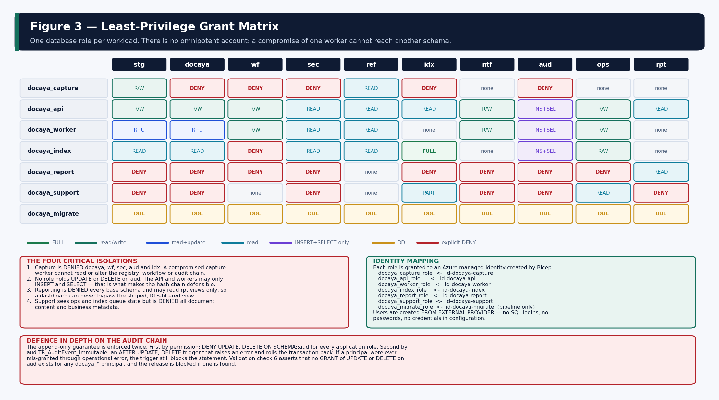
Figure 3 — The grant matrix. Seven roles, ten schemas, and the explicit denials that isolate each workload.

8.1 Roles and Identity Mapping
Database role | Managed identity | Granted | Explicitly denied
docaya_capture_role | id-docaya-capture | stg (read/write), ref (read) | docaya, wf, sec, aud, idx
docaya_api_role | id-docaya-api | docaya, wf, ntf, ops, stg (read/write); ref, idx, rpt, sec (read); aud (INSERT + SELECT) | UPDATE/DELETE on aud; DELETE on docaya; writes to sec.AccessPolicy and ref
docaya_worker_role | id-docaya-worker | wf, ops, ntf (read/write); docaya, stg (read + update); aud (INSERT) | UPDATE/DELETE on aud; all writes to sec
docaya_index_role | id-docaya-index | idx (full); docaya, ref, sec, stg (read); ops (read/write); aud (INSERT) | writes to docaya and wf
docaya_report_role | id-docaya-report | rpt views (SELECT only) | every base schema
docaya_support_role | id-docaya-support | ops (read); idx queue and reconcile (read) | docaya, stg, aud, sec, ntf, rpt
docaya_migrate_role | id-docaya-migrate | ALTER / DDL on every schema; release pipeline only | no data-plane SELECT on document content

8.2 The Four Critical Isolations
- The capture worker is denied the registry. Even if the upload path were compromised, it cannot read or alter documents, workflow state, access policy or the audit chain.
- No application role holds UPDATE or DELETE on aud. The API and workers may only INSERT and SELECT, which is what makes the hash chain defensible in an audit.
- Reporting is denied every base schema and may read rpt views only, so a dashboard can never bypass the shaped, row-level-security-filtered view.
- Support sees operational state — queue depth, dead-letter, job runs, index reconcile — but is denied all document content and business metadata.

8.3 Row-Level Security
rls.fn_DepartmentPredicate mirrors the Docaya department scope so a Power BI dashboard shows exactly what the viewer could see in the application. The predicate reads SESSION_CONTEXT keys that the embed-token service sets per user.
SESSION_CONTEXT key | Meaning
DocayaAllDepartments | Set to 1 for platform-wide readers — System Administrator, Records & Compliance Officer, Auditor.
DocayaDepartmentId | The viewer's own department; matches ref.Department.DepartmentId.
DocayaDepartmentIds | A JSON array for explicitly granted cross-department visibility.

The policy ships disabled rls.DocayaDepartmentRls is created WITH (STATE = OFF). Enable it during Phase 13 (Analytics) only after the embed-token service is confirmed to populate SESSION_CONTEXT — otherwise every report returns zero rows.

8.4 Encryption and Data Protection
Control | Design
Encryption at rest | Transparent Data Encryption enabled. Customer-managed keys are available where client policy requires them (open item A9).
Encryption in transit | TLS 1.2 or higher enforced; the database is reachable only over a private endpoint with public network access disabled.
Sensitive columns | Always Encrypted is a candidate for specific columns subject to decision A9; the schema does not presuppose it.
Authentication | Microsoft Entra authentication with managed identity. No SQL authentication and no shared administrator account in normal operation.
Break-glass | An emergency database principal may exist but is disabled by default, requires approval to enable, expires automatically and is session-logged.
Auditing | Azure SQL auditing enabled to Log Analytics, independent of and in addition to the application-level aud schema.

9. Programmability
Four functions and seven procedures. Logic is placed in the database only where correctness depends on serialisation, atomicity or set-based evaluation; all business rules remain in the application domain layer.
Object | Type | Purpose
ref.fn_IsWorkingDay | Scalar function | DATEFIRST-independent weekday test against the versioned calendar and weekend pattern.
ref.fn_AddWorkingDays | Scalar function | Sets OriginalTargetUtc at submission — Urgent 12, Normal 30 working days.
ref.fn_WorkingDaysBetween | Scalar function | The remaining-working-days counter shown on every in-flight request.
rls.fn_DepartmentPredicate | Inline TVF | The row-level security filter predicate for reporting.
docaya.usp_IssueTrackingNumber | Procedure | Atomic DOC-YYYY-NNNNNN issuance using MERGE with HOLDLOCK.
aud.usp_AppendAuditEvent | Procedure | Appends one audit row and computes the chain hash under an application lock.
aud.usp_VerifyChain | Procedure | Recomputes the chain from the last good checkpoint and reports every broken link.
wf.usp_ResolveRoute | Procedure | Resolves the review route: Department beats Class beats Global; most specific wins.
wf.usp_SweepSlaStatus | Procedure | Timer job. Raises AtRisk and Overdue exactly once each and records the SLA events.
ops.usp_EnqueueOutbox | Procedure | Transactional outbox write; called inside the same transaction as the state change.
docaya.usp_PurgeStagingArtifacts | Procedure | M5 staging reconciliation. Never touches the registry or the audit chain.

9.1 Why the weekday calculation is DATEFIRST-independent
DATEPART(WEEKDAY, …) depends on the session DATEFIRST setting, which differs between connection libraries and language settings. A working-day calculation that varies by session is not acceptable for a contractual SLA, so the function anchors on a known date instead.
-- 1900-01-01 was a Monday, so this yields 1 = Sunday .. 7 = Saturday
-- regardless of the session DATEFIRST setting.
DECLARE @dow TINYINT = ((DATEDIFF(DAY, 0, @Date) + 1) % 7) + 1;

IF EXISTS (SELECT 1 FROM ref.WorkingWeek
WHERE CalendarCode = @CalendarCode AND VersionNo = @VersionNo
AND DayOfWeekNo = @dow AND IsWorkingDay = 0)
RETURN 0;
IF EXISTS (SELECT 1 FROM ref.HolidayCalendar
WHERE CalendarCode = @CalendarCode AND VersionNo = @VersionNo
AND HolidayDate = @Date)
RETURN 0;
RETURN 1;

Validation check 21 performs a live round trip — twelve working days forward, then twelve counted back — and blocks the release if the result is not exactly 12.

10. Data Flow and Deployment Summary
The nine governed lifecycle steps map onto the schemas in a strict order. Nothing writes to docaya until a tracking number exists, and nothing reaches idx until the document is Published. The diagram overleaf shows which tables each step touches.

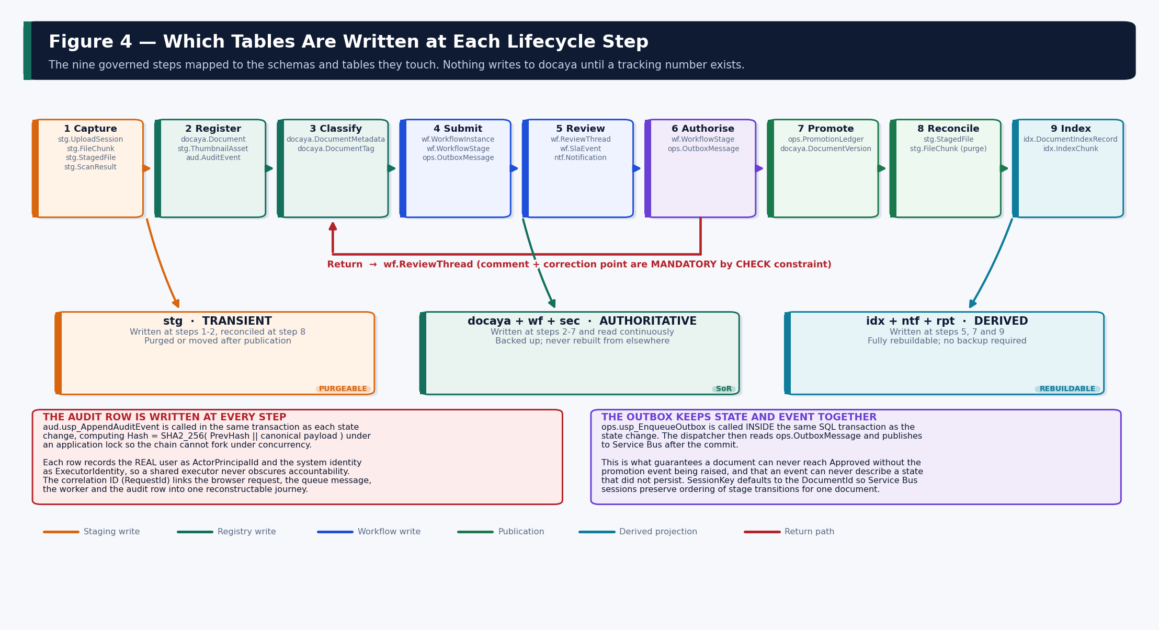
Figure 4 — Which tables are written at each of the nine governed lifecycle steps.

10.1 Script Execution Order
Full installation instructions are in the companion Azure SQL Deployment Guide. The order is reproduced here for reference.
# | Script | Creates
00 | 00_master_deploy.sql | Manifest and environment banner (informational; no DDL).
01 | 01_schemas_and_principals.sql | Ten schemas, seven database roles, workload users FROM EXTERNAL PROVIDER.
02 | 02_ref_reference_data.sql | 14 catalogue tables including the metadata schema and working-day calendar.
03 | 03_sec_access_control.sql | 7 tables: principals, roles, RBAC assignments, ABAC attributes, policy, decision log.
04 | 04_docaya_core_registry.sql | 8 registry tables plus the six hot-path indexes on docaya.Document.
05 | 05_stg_staging.sql | 6 staging tables with the one-file-per-registration and 100 MB constraints.
06 | 06_wf_workflow_sla.sql | 6 workflow tables including the mandatory return-comment and extension-reason checks.
07 | 07_idx_index_projection.sql | 5 projection tables including the published-only constraint.
08 | 08_ntf_notification.sql | 6 notification tables including the de-duplication unique index.
09 | 09_aud_audit.sql | 3 audit tables and the immutability trigger.
10 | 10_ops_operational.sql | 6 operational tables including the promotion ledger.
11 | 11_rpt_reporting_views.sql | 9 reporting views shaped for the Power BI semantic model.
12 | 12_programmability.sql | 4 functions and 7 stored procedures.
13 | 13_security_grants.sql | 63 GRANT and 29 DENY statements plus the RLS predicate and policy.
14 | 14_seed_reference_data.sql | Seed data: statuses, transitions, roles, catalogues, calendar, SLA targets, default route.
15 | 15_validation_checks.sql | 22 blocking assertions; THROWs on any failure.

11. Seed Data and Open Items
The deployment seeds a working baseline so the platform is operable on first start. Several values are placeholders that require client confirmation before go-live; each is marked in 14_seed_reference_data.sql with its open-item reference from the Technical Architecture Document, Section 3.4.

11.1 What Is Seeded
Catalogue | Seeded | Confirmation required
ref.Status | 12 lifecycle states from PendingRegistration to Disposed. | No — derived from the v1.3 state machine.
ref.StatusTransition | 19 allowed transitions. Any move not listed is rejected. | No — derived from TAD Figure 5.
ref.Sensitivity | Public, Internal, Confidential, Secret with clearance ranks 1–4. | Handling markings to be confirmed (A2).
ref.PublishingScope | Departmental, Cross-Departmental, Organisation-wide, Public. | No — defined in v1.3.
ref.Priority | Routine, Priority, Urgent mapped to Normal / Urgent request types. | No.
ref.DocumentClass | 8 classes with their SharePoint library names and thumbnail-suppression flags. | Yes — class list and library map (A2).
ref.Department | 6 departments with spoke-site URLs. | Yes — departmental structure and site map (A2).
ref.Standard | 5 standards with folder segments. | Yes — Standard taxonomy (A2).
ref.RetentionPolicy | 5 policies covering standard, contract, HR, correspondence and superseded content. | Yes — Records sign-off required (A2).
sec.Role | 12 application roles with their capability flags. | No — derived from TAD Section 14.4.
ref.WorkingWeek | UAE weekend: Saturday and Sunday non-working; Friday working. | Yes — confirm against client practice (A4).
ref.HolidayCalendar | Intentionally EMPTY. | Yes — client-supplied UAE public holidays (A4).
ref.SlaTarget | Urgent 12 working days (3-day warning), Normal 30 (5-day warning). | Yes — confirm targets and window (A3).
ntf.NotificationType | 16 types across 9 categories; security types flagged mandatory. | No — derived from TAD Section 25.1.
wf.RouteDefinition | GLOBAL-4STAGE: Editor → Owner → Assurance → Authoriser. | Yes — stage variants per type or department (A3).

The holiday calendar must be loaded before go-live ref.HolidayCalendar is deliberately seeded empty. The weekend pattern is set, but the working-day SLA engine should not be trusted in production until the client-supplied UAE public holidays are loaded. Amending the calendar creates a new VersionNo; affected in-flight instances are recalculated and logged as a Recalculated SLA event rather than silently changed.

11.2 Open Items
Ref | Item | Seeded default | Owner
A2 | Document classes, departments, Standard taxonomy, SharePoint library map. | 8 classes · 6 departments · 5 standards | PMO / Records
A3 | Stage count per document type, parallel and quorum rules, correction-point behaviour. | Single global four-stage chain | PMO
A3 | SLA targets and at-risk warning window. | 12 / 30 working days; 3 / 5-day warning | PMO
A4 | Working-day calendar, weekend pattern and public holidays. | Sat + Sun weekend; calendar empty | Client HR / PMO
A2 | Retention schedules and disposition actions. | 5 placeholder policies | Records & Compliance
A9 | Customer-managed keys and Always Encrypted for sensitive columns. | Platform-managed keys; Always Encrypted not applied | Client Security
— | Row-level security activation and the SESSION_CONTEXT contract. | Policy created with STATE = OFF | Architecture / Analytics

12. Requirement Traceability
Every functional requirement that has a database consequence is mapped to the object that implements it. A requirement without a row here has no database dependency.
Requirement | Implemented by | Verified by
FR-CAP-01 — one file per registration | UX_UploadSession_OpenPerDoc (filtered unique) | Validation check 12
FR-CAP-02 — maximum 100 MB, resumable | CK_Session_Size · CK_Staged_Size · CK_Version_Size · stg.FileChunk | Validation check 11
FR-CAP-03 — original stored unchanged | stg.StagedFile.Sha256 compared to ops.PromotionLedger.PublishedHash | Validation check 4
FR-CAP-04 — tracking number issued immediately | docaya.usp_IssueTrackingNumber · UQ_Document_Tracking · CK_Document_Tracking | Validation check 3
FR-CAP-05 — malware and DLP before submission | stg.ScanResult with CHECK on Verdict | Application gate + scan row
FR-CAP-06 — technical extraction only | stg.ExtractionResult carries no classification columns by design | Schema review
FR-CAP-07 — manual classification | docaya.Document FKs to the ref catalogues; all NOT NULL | Schema review
FR-CAP-08 — metadata validated against type schema | ref.MetadataSchema · ref.MetadataField · docaya.DocumentMetadata.SchemaId | Schema review
FR-CAP-11 — Department Tag and Publishing Scope | docaya.DocumentTag · UX_DocumentTag_Owning · ref.PublishingScope | Validation check 13
FR-WF-01 — configurable 3 or 4 stage chain | wf.RouteDefinition.StageCount with CK_Route_Stages | Validation check 14
FR-WF-02 — sequential, parallel, quorum, conditional | wf.RouteStage.PatternCode with CK_Stage_Pattern and CK_Stage_Quorum | Schema review
FR-WF-03 — return requires comment and correction point | CK_Thread_ReturnComment | Validation check 9
FR-WF-04 — resubmission resumes at the correction point | wf.ReviewThread.CorrectionPointStageNo · wf.WorkflowStage.AttemptNo | Integration test
FR-WF-05 — 12 / 30 working-day targets | ref.SlaTarget · ref.fn_AddWorkingDays · ref.HolidayCalendar | Validation checks 18, 21
FR-WF-06 — at-risk, overdue, stage duration visible | wf.SlaEvent · wf.WorkflowStage.DurationWorkingMinutes · wf.usp_SweepSlaStatus | rpt.vwStageBottleneck
FR-WF-07 — extension retains original target | Separate target columns · CK_WfInst_Target · CK_Sla_ExtensionReason | Validation check 10
FR-WF-08 — one idempotent promotion command | UQ_PromotionLedger_Idempotency | Validation check 4
FR-PUB-01 — published hash equals staged hash | CK_Promo_SuccessNeedsHash | Validation check 4
FR-PUB-02 — SharePoint coordinates written back | docaya.DocumentVersion.SpSiteId / SpDriveId / SpItemId / SpWebUrl | Integration test
FR-PUB-05 / 06 — only approved content indexed | CK_IdxRec_PublishedOnly · rpt.vwIndexHealth | Validation check 8
FR-PUB-09 — exactly one alert per recipient | UX_Notification_Dedup | Validation check 15
FR-PUB-10 — first-login reading list | ntf.ReadingList with acknowledgement tracking | Integration test
FR-CORE-02 — retention and legal-hold override | ref.RetentionPolicy · docaya.LegalHold · UX_LegalHold_Active · filtered sweep indexes | Schema review
FR-CORE-07 — deny by default, every decision audited | sec.AccessPolicy · sec.AccessDecisionLog · aud.AuditEvent | Security test
FR-GOV-02 — revision starts from the approved version | CK_WfInst_BaseVersion | Schema review
FR-GOV-03 — final approval creates the next version | docaya.DocumentVersion.SupersededByVersionId · UQ_DocumentVersion_Seq | Integration test
FR-GOV-04 — permission-trimmed reporting | rpt.* views · rls.fn_DepartmentPredicate · DENY on base schemas | Validation check 20
FR-GOV-05 — hash-chained audit of every event | aud.AuditEvent · aud.usp_AppendAuditEvent · TR_AuditEvent_Immutable | Validation checks 5, 6

13. Appendices

A. Object Inventory
Object type | Count | Notes
Schemas | 10 | stg · docaya · wf · sec · ref · idx · ntf · aud · ops · rpt (plus rls for the RLS predicate)
Tables | 63 | Distributed across nine data schemas; rpt contains views only
Foreign keys | 92 | All resolve forward in the deployment order; none cascade into a business schema
Check constraints | 68 | Including the 16 architectural guarantees listed in Section 6.1
Explicit indexes | 58 | 28 filtered, 14 covering, 9 unique-filtered expressing business rules
Views | 9 | All in rpt; the Power BI semantic model reads nothing else
Stored procedures | 7 | Serialisation, atomicity and set-based work only
Functions | 4 | 3 scalar (working-day arithmetic) plus 1 inline TVF (RLS predicate)
Triggers | 1 | aud.TR_AuditEvent_Immutable
Database roles | 7 | One per workload identity
GRANT statements | 63 | Least privilege per role
DENY statements | 29 | Explicit isolation, most importantly capture from the registry and reporting from base tables

B. Naming Conventions
Object | Convention | Example
Table | {schema}.{PascalCase singular} | docaya.DocumentVersion
Primary key | PK_{Table} | PK_DocumentVersion
Foreign key | FK_{Table}_{Target} | FK_Version_Document
Unique constraint | UQ_{Table}_{Purpose} | UQ_Document_Tracking
Unique filtered index | UX_{Table}_{Purpose} | UX_DocumentTag_Owning
Non-clustered index | IX_{Table}_{Columns or purpose} | IX_Document_Dept_Status
Check constraint | CK_{Table}_{Rule} | CK_Promo_SuccessNeedsHash
Default | DF_{Table}_{Column} | DF_Doc_Hold
Procedure | {schema}.usp_{Verb}{Noun} | aud.usp_AppendAuditEvent
Function | {schema}.fn_{Purpose} | ref.fn_AddWorkingDays
View | rpt.vw{Subject} | rpt.vwStageBottleneck
Database role | docaya_{workload}_role | docaya_capture_role

C. Glossary
Term | Meaning
Authoritative schema | A schema whose content cannot be reconstructed from any other source and therefore requires backup: docaya, wf, sec, aud.
Derived schema | A schema rebuildable from authoritative data: idx and rpt. No backup requirement.
Correction point | The stage at which a returned document re-enters the review chain, recorded on the thread entry.
Department Tag | The owning department plus any related departments, held as rows in docaya.DocumentTag.
Idempotency key | A value that makes a repeated write produce one effect; the mechanism behind exactly-once promotion.
Promotion | Publication of the approved, unchanged native file into the resolved SharePoint library.
Publishing Scope | How widely an approved document is published, which determines the reach of the publication broadcast.
Security key | A permission token derived from RBAC and ABAC at request time and applied as a search filter and post-retrieval trim.
Working day | A day that is neither a configured weekend day nor a date in the versioned holiday calendar.

Approval to deploy Endorsement of this Database Design Document authorises deployment of the Docaya database schema into the development and test environments. Production deployment additionally requires the open items in Section 11.2 to be closed — in particular the working-day calendar (A4), the document class and department map (A2), and the retention schedules.

— End of Document —

